QUERY 1:

PREFIX rdf: <http://www.w3.org/1999/02/22-rdf-syntax-ns#>

PREFIX rdfs: <http://www.w3.org/2000/01/rdf-schema#>

PREFIX dbpediaowl: <http://dbpedia.org/ontology/>

SELECT ?uscStudents AS ?USC_STUDENT_COUNT ?uclaStudents AS ?UCLA_STUDENT_COUNT WHERE {

<http://dbpedia.org/resource/University_of_Southern_California> dbpedia-owl:numberOfStudents ?uscStudents .

<http://dbpedia.org/resource/University_of_California,_Los_Angeles> dbpedia-owl:numberOfStudents ?uclaStudents

}



QUERY 2:

PREFIX rdf: <http://www.w3.org/1999/02/22-rdf-syntax-ns#>

PREFIX rdfs: <http://www.w3.org/2000/01/rdf-schema#>

PREFIX dbpediaowl: <http://dbpedia.org/ontology/>

PREFIX dbpprop: <http://dbpedia.org/property/>

PREFIX dbpedia: <http://dbpedia.org/resource/>

SELECT DISTINCT ?universityName AS ?UNIVERSITY_NAME WHERE

{

{

?privateUniversitiesInLA <http://dbpedia.org/ontology/type> <http://dbpedia.org/resource/Private_university> .

}

UNION

{

?privateUniversitiesInLA <http://dbpedia.org/property/type> <http://dbpedia.org/resource/Private_university> .

}

{

?privateUniversitiesInLA dbpprop:location <http://dbpedia.org/resource/Los_Angeles>

}

UNION

{

?privateUniversitiesInLA dbpedia-owl:city <http://dbpedia.org/resource/Los_Angeles>

}

?privateUniversitiesInLA dbpedia-owl:numberOfStudents ?numberOfStudents .

?privateUniversitiesInLA rdfs:label ?universityName

FILTER (LANGMATCHES(LANG(?universityName), 'en'))

}

ORDER BY DESC(?numberOfStudents)

LIMIT 10

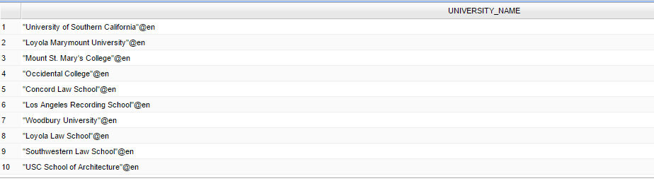

QUERY 3:

PREFIX rdf: <http://www.w3.org/1999/02/22-rdf-syntax-ns#>

PREFIX rdfs: <http://www.w3.org/2000/01/rdf-schema#>

PREFIX dbpprop: <http://dbpedia.org/property/>

PREFIX dbpp: <http://dbpedia.org/property/>

PREFIX dbp: <http://dbpedia.org/property/>

PREFIX dbpedia: <http://dbpedia.org/resource/>

PREFIX db: <http://dbpedia.org/>

PREFIX dbpr: <http://dbpedia.org/resource/>

PREFIX dbprop: <http://dbpedia.org/property/>

SELECT DISTINCT ?campusType AS ?CAMPUS_TYPE, count(?publicUniversitiesInLA) as ?NUMBER_OF_UNIVERSITIES WHERE

{

{

?publicUniversitiesInLA <http://dbpedia.org/ontology/type> <http://dbpedia.org/resource/Public_university> .

}

{

{

?publicUniversitiesInLA dbpprop:location <http://dbpedia.org/resource/Los_Angeles> .

}

UNION

{

?publicUniversitiesInLA dbpedia-owl:city <http://dbpedia.org/resource/Los_Angeles> .

}

}

{?publicUniversitiesInLA dbpprop:campus ?campusType .}

UNION

{?publicUniversitiesInLA dbpprop:campusType ?campusType .}

}GROUP BY (?campusType)

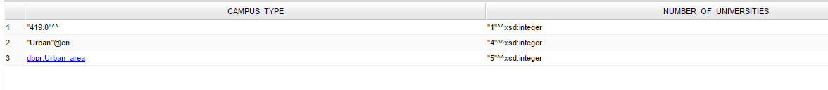

QUERY 4:

PREFIX rdf: <http://www.w3.org/1999/02/22-rdf-syntax-ns#>

PREFIX rdfs: <http://www.w3.org/2000/01/rdf-schema#>

PREFIX dbpprop: <http://dbpedia.org/property/>

PREFIX dbpp: <http://dbpedia.org/property/>

PREFIX dbp: <http://dbpedia.org/property/>

PREFIX dbpedia: <http://dbpedia.org/resource/>

PREFIX db: <http://dbpedia.org/>

PREFIX dbpr: <http://dbpedia.org/resource/>

PREFIX dbprop: <http://dbpedia.org/property/>

PREFIX xsd: <http://www.w3.org/2001/XMLSchema#>

SELECT DISTINCT ?universityName AS ?UNIVERSITY_NAME WHERE

{

{

{?universities <http://dbpedia.org/ontology/type> <http://dbpedia.org/resource/Private_university> .}

UNION

{?universities <http://dbpedia.org/property/type> <http://dbpedia.org/resource/Private_university> .}

UNION

{?universities <http://dbpedia.org/ontology/type> <http://dbpedia.org/resource/Public_university> .}

UNION

{?universities <http://dbpedia.org/property/type> <http://dbpedia.org/resource/Public_university> .}

}

{?universitiesInLA dbpprop:location <http://dbpedia.org/resource/Los_Angeles> .}

UNION

{?universitiesInLA dbpedia-owl:city <http://dbpedia.org/resource/Los_Angeles> .}

?universitiesInLA rdfs:label ?universityName

FILTER (LANGMATCHES(LANG(?universityName), 'en'))

?universitiesInLA dbpprop:established ?establishedUniversities

BIND (xsd:integer(substr(xsd:string(?establishedUniversities),1,4)) AS ?sortedYears) .

FILTER (?sortedYears < 1915)

}ORDER BY DESC(?sortedYears)

LIMIT 10

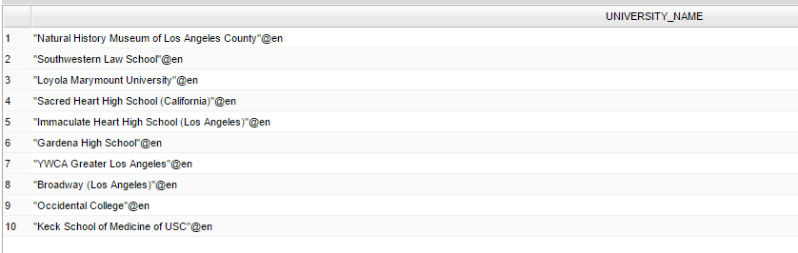

QUERY 5:

PREFIX rdf: <http://www.w3.org/1999/02/22-rdf-syntax-ns#>

PREFIX rdfs: <http://www.w3.org/2000/01/rdf-schema#>

PREFIX dbpprop: <http://dbpedia.org/property/>

PREFIX xsd: <http://www.w3.org/2001/XMLSchema#>

SELECT DISTINCT (?albumString) AS ?ALBUM_NAMES SUM(?lengthInInteger) AS ?LENGTH WHERE {

?albumNames dbpprop:totalLength ?totalLength .

?albumNames dbpprop:name ?albumString .

?albumNames dbpprop:length ?length .

BIND(xsd:integer(?length) AS ?lengthInInteger)

?albumNames <http://dbpedia.org/property/title> ?songNames .

{SELECT ?albumNames WHERE {?albumNames <http://dbpedia.org/ontology/artist> <http://dbpedia.org/resource/Megadeth> .}}

}

GROUP BY (?albumString)

HAVING (count(?songNames)>10)

ORDER BY(?albumString)

LIMIT 10

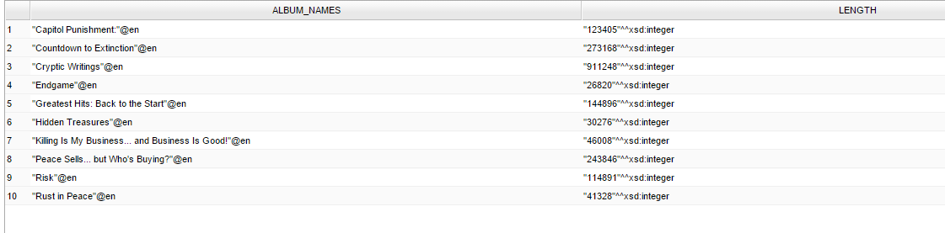

I have fetched all the albums of the band called Megadeth. And summed up the length of all the songs (the run time of the albums). Sorted it in alphabetically order of the album. And also, only albums with only more than 10 songs.